- Create the DEPT table based on the following table instance chart.
CREATE TABLE DEPT( ID NUMBER(7) NOT NAME VARCHAR2(25) NOT NULL,
CONSTRAINT ID_PK PRIMARY KEY(ID) );

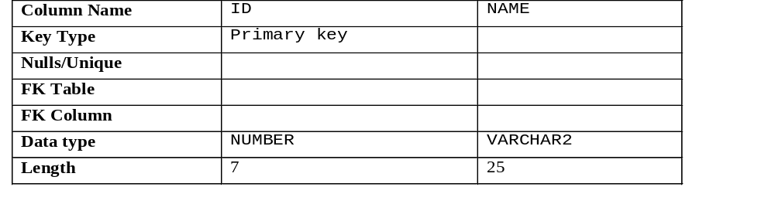

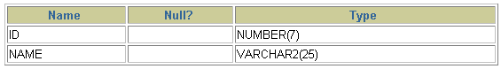

- Populate the DEPT table with data from the DEPARTMENTS table. Include only columns that you need.
INSERT INTO DEPT VALUES(1800, ’NAVEEN’);

- Create the EMP table based on the following table instance chart. Confirm that the table IS created.
CREATE TABLE EMP(
ID NUMBER(8) NOT NULL,
LAST_NAME VARCHAR2(25) NOT NULL,
FIRST_NAME VARCHAR2(25) NOT NULL,
DEPT_ID NUMBER(7) NOT NULL,
CONSTRAINT DEPT _ID_PK FOREIGN KEY (DEPT_ID)
REFERENCES DEPT(DEPT_ID) );

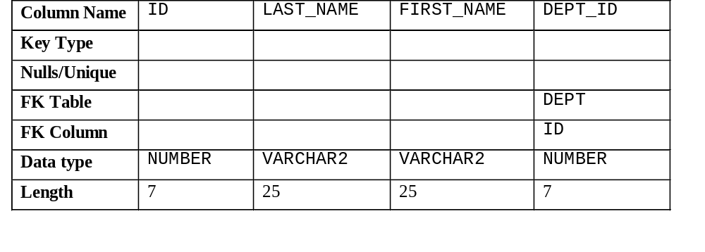

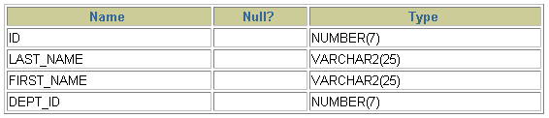
- Create the EMPLOYEES2 table based on the structure of the EMPLOYEES table. Include only the EMPLOYEE_ID, FIRST_NAME, LAST_NAME, SALARY, and DEPARTMENT_ID columns. Name the columns in your new table ID, FIRST_NAME, LAST_NAME, SALARY , and DEPT_ID, respectively.
CREATE TABLE EMPLOYEE2 (
EMPLOYEE_ID NUMBER(8) NOT NULL ,
FIRST _NAME VARCHAR2(20) NOT NULL,
LAST_NAME VARCHAR2(20) NOT NULL,
SALARY NUMBER(8) NOT NULL,
CONSTRAINT EMPLOYEE_ID_PK PRIMARY KEY(EMPLOYEE_ID) ,
CONSTRAINT SAL_SL CHECK(‘SAL’>0 ) );

5. Drop the EMP table.
DROP TABLE EMP ;

